**NAME- DEVANSHU SURANA**

**ELECTIVE ROLL NO-BT1-18**

**PANEL ROLL NO- PC-23**

**PRN-1032210755**

**PANEL-C**

**Assignment 3**

**Study and understand the various statistics observations related to Bitcoin and Ethereum**

**1). Aim :** To study and understand the various statistics observations related to Bitcoin and Ethereum.

**2). Objectives :**

* Analyze transactional data on Etherscan and Blockchain.com for insights into Ethereum and Bitcoin transactions.
* Explore the features of Etherscan and Blockchain.com, understanding how they provide information on blockchain transactions and addresses.
* Examine transparency and traceability of Ethereum and Bitcoin transactions using Etherscan and Blockchain.com.
* Evaluate user interfaces and data visualization tools on Etherscan and Blockchain.com for Ethereum and Bitcoin blockchain data.

**3). Theory :**

1. Working of Ethereum

* Ethereum operates as a decentralized, open-source blockchain platform, enabling the creation and execution of smart contracts and decentralized applications (DApps). At its core, Ethereum employs a blockchain, a distributed ledger that records all transactions across a network of computers. Smart contracts, self-executing code with predefined rules, facilitate automated and trustless agreements. Ethereum's native cryptocurrency, Ether (ETH), is used for transaction fees and computational services on the network.
* Miners, participating nodes in the network, validate transactions and add new blocks to the blockchain through a process called proof-of-work, although Ethereum is transitioning to a proof-of-stake consensus mechanism. This ensures security and immutability of the blockchain. Ethereum's versatility lies in its ability to support various tokens and DApps, fostering a thriving ecosystem for decentralized finance, non-fungible tokens, and more, making it a foundational platform for blockchain-based innovations.

1. Working of Bitcoin

* Bitcoin operates on a decentralized peer-to-peer network using blockchain technology. Transactions are added to blocks through a process called mining, where network participants, known as miners, use powerful computers to solve complex mathematical puzzles. Once a puzzle is solved, the miner broadcasts the solution to the network, and the proposed block is verified by other nodes. This consensus mechanism ensures the integrity of the ledger. Successfully mined blocks are linked to the existing chain, creating a chronological and immutable record of transactions. Miners are rewarded with newly minted bitcoins for their efforts.
* Additionally, the Bitcoin network has a fixed supply of 21 million coins, controlled by a process called halving, which reduces the reward given to miners approximately every four years. This scarcity contributes to Bitcoin's value proposition as a deflationary and decentralized digital currency. Users transact pseudonymously using cryptographic addresses, and the security of the network relies on the robustness of its decentralized architecture and cryptographic principles.

1. Main functionalities provided by EtherScan,io

* Etherscan offers a comprehensive set of functionalities for users exploring the Ethereum blockchain:
* Transaction Tracking: Users can monitor real-time and historical transaction details, including sender/receiver addresses, timestamps, and transaction values.
* Address Information: It provides insights into Ethereum addresses, displaying transaction history, token holdings, and balances.
* Smart Contract Exploration: Etherscan allows users to analyze smart contracts, view their source code, and explore interactions on the Ethereum Virtual Machine (EVM).
* Token Analytics: Users can track and manage Ethereum-based tokens, reviewing details such as token transfers, holdings, and contract information.
* Network Statistics: Etherscan provides an overview of Ethereum network statistics, including block details, mining information, and network health.
* Rich List: Users can identify top token holders and view distribution statistics.
* These functionalities make Etherscan a valuable tool for blockchain enthusiasts, developers, and researchers.

**4). Implementation :**

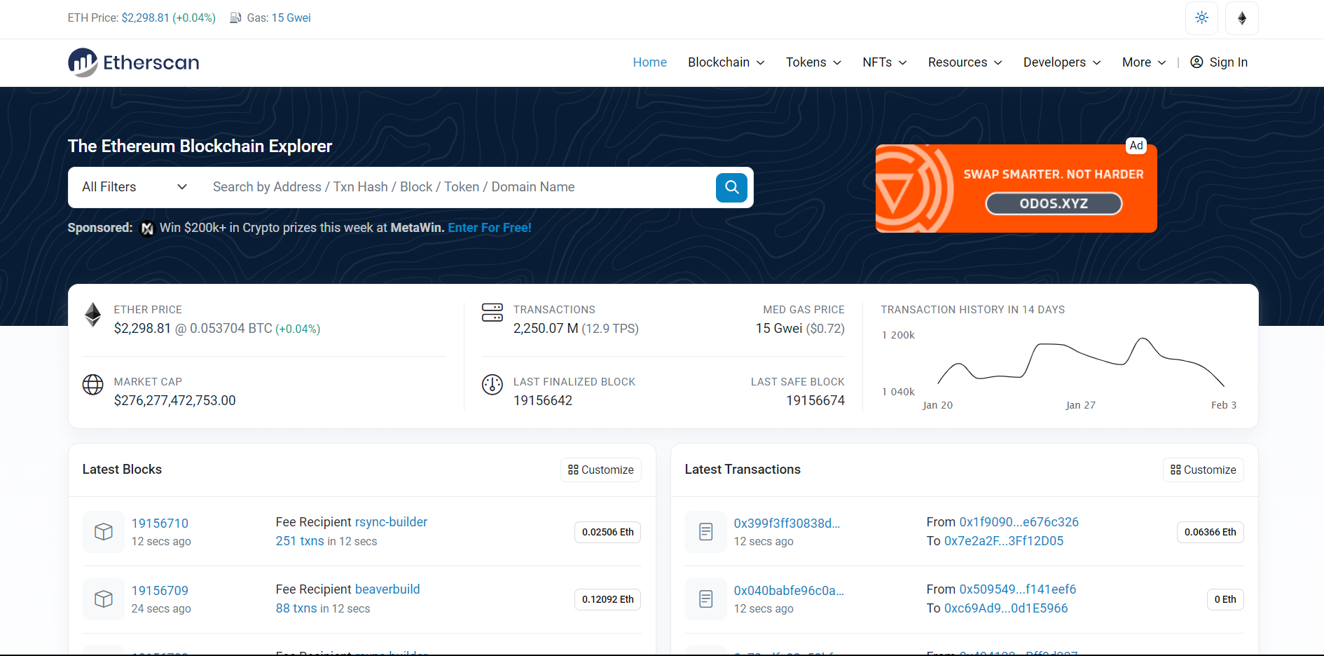

3.1). Home Page of Etherscan.io

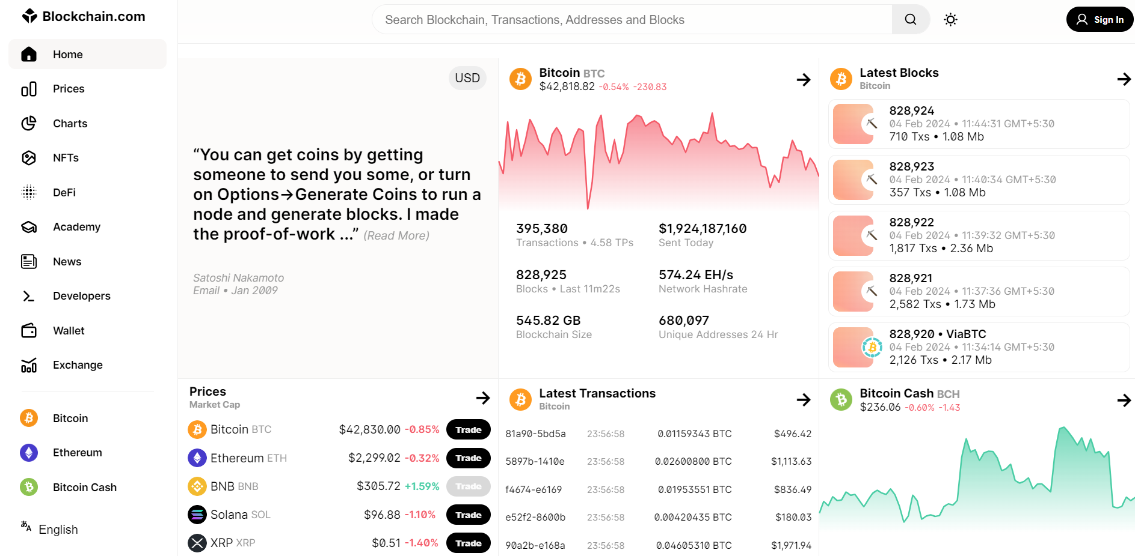

3.2). Home Page of Blockchain.com

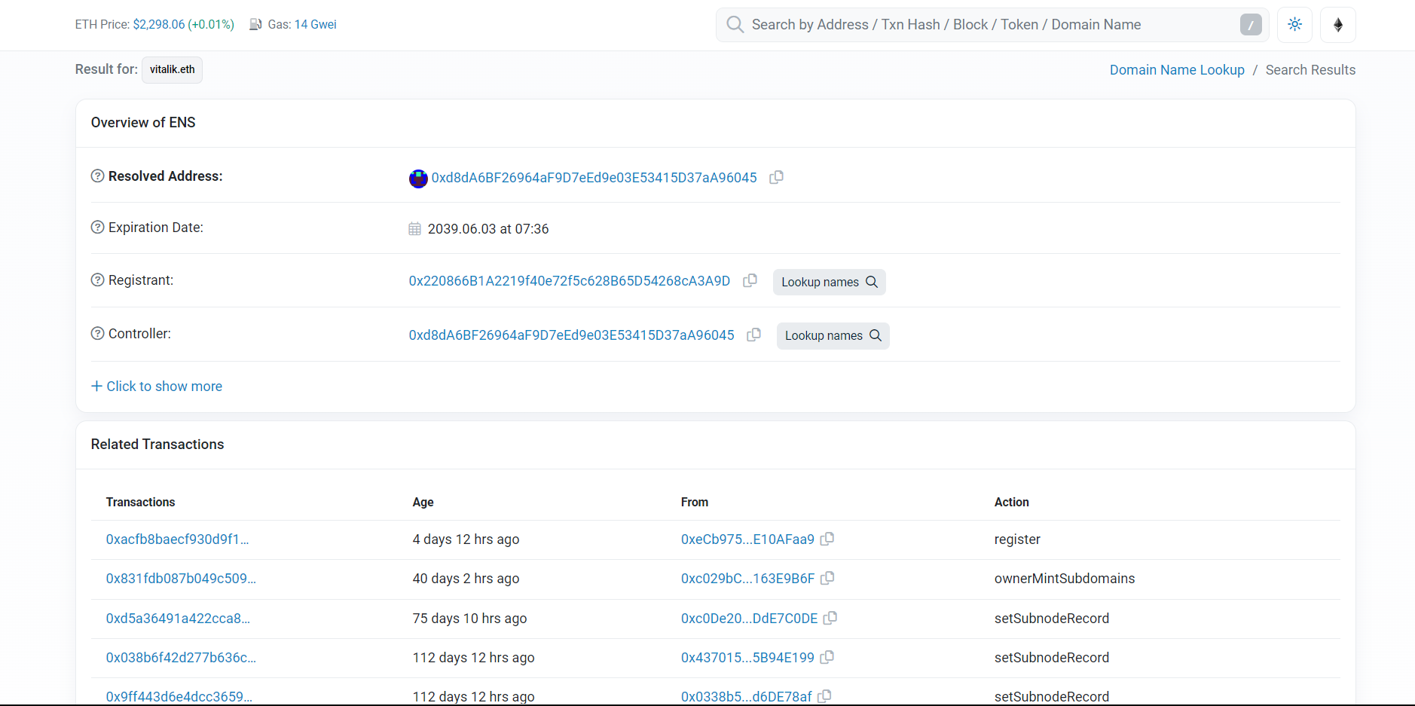

3.3). Vitalik Buterin’s wallet information on Etherscan.io

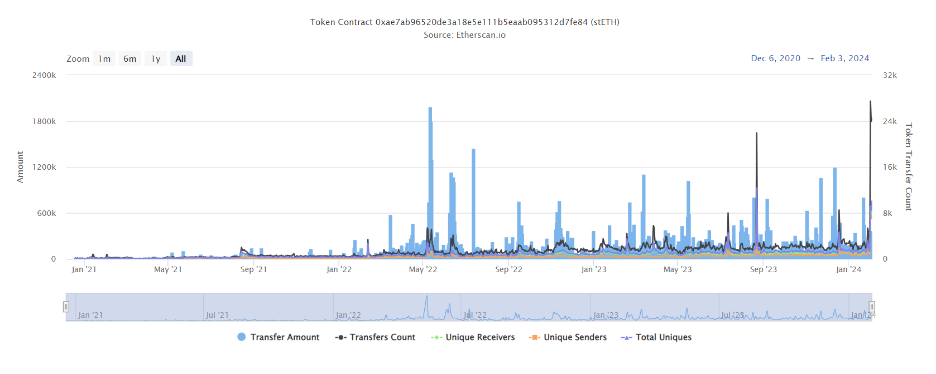

3.4). Ethereum transaction analytics

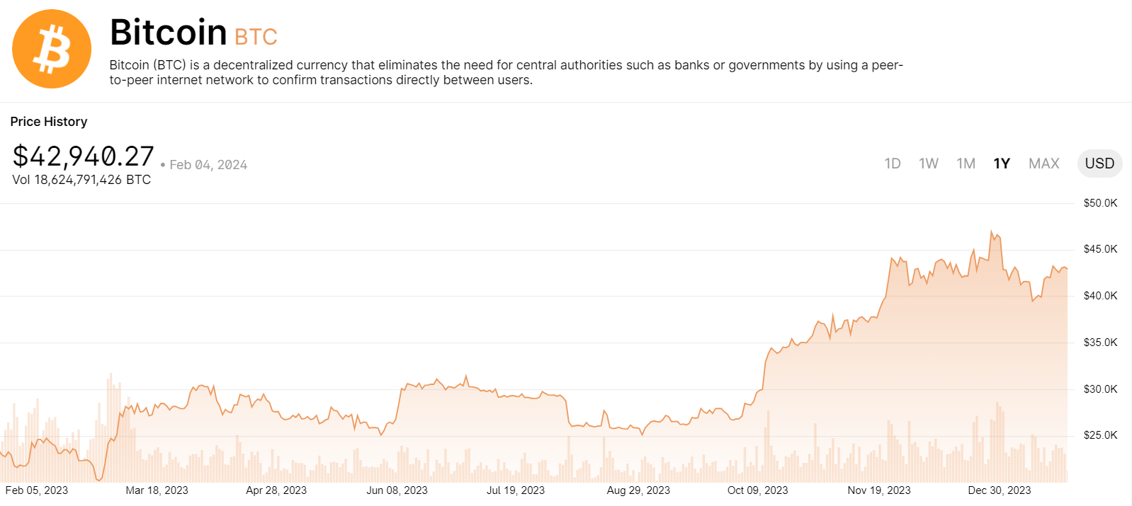

3.5). Bitcoin transaction analytics

**5). FAQs :**

Q1). Differentiate between Bitcoin and Ethereum.

* Bitcoin and Ethereum, the two most prominent cryptocurrencies, differ in their fundamental purposes and functionalities. Bitcoin, created by an anonymous entity, serves as a decentralized digital currency. Its primary function is facilitating peer-to-peer transactions and serving as a store of value. Ethereum, developed by Vitalik Buterin, is a broader platform designed to enable smart contracts and decentralized applications (DApps). Ethereum's scripting language allows for the creation of complex self-executing contracts, extending its use beyond simple transactions.
* Here is a table summarizing the key differences between Bitcoin and Ethereum:

|  | Bitcoin | Ethereum |
| --- | --- | --- |
| Purpose | Store of value, medium of exchange | Platform for decentralized applications |
| Technology | Proof-of-Work | Proof-of-Stake |
| Transactions | 7 transactions per second | 30 transactions per second |
| Supply | 21 million limit | Unlimited |
| Use cases | Digital money | DeFi, NFTs, DAOs |
| Price | Leads entire crypto market | Follows Bitcoin, leads DeFi, NFTs, DAOs |

Q2). What are wallets in the context of cryptocurrency?

* In the context of cryptocurrency, wallets are digital tools that enable users to store, manage, and interact with their digital assets. A cryptocurrency wallet stores the user's public and private keys, allowing them to send and receive various cryptocurrencies. Wallets come in different forms, including hardware wallets, software wallets (desktop or mobile applications), and online wallets.
* Each type has its advantages and trade-offs in terms of security, convenience, and accessibility. Wallets play a crucial role in providing users with control and ownership of their digital currencies.

Q3). What is gas value? Explain it’s significance.

* Gas in the context of Ethereum refers to the computational cost required to execute operations or run smart contracts on the Ethereum blockchain. Gas is denominated in Ether (ETH) and is a crucial aspect of the Ethereum network's functionality. Users set a gas limit and gas price when initiating transactions or executing smart contracts.
* The gas limit determines the maximum computational effort allowed for a transaction, while the gas price indicates the amount of Ether paid per unit of gas. Understanding gas is significant as it influences the speed and cost of transactions, and users must balance these factors based on their preferences and requirements. Efficiently managing gas is essential for optimizing transaction processing on the Ethereum network.

Q4). Explain in brief what are smart contracts.

* Smart contracts are self-executing programs with coded agreements that automatically execute and enforce the terms of a contract when predefined conditions are met. Utilizing blockchain technology, smart contracts eliminate the need for intermediaries, ensuring transparency, security, and efficiency in contractual agreements.
* These contracts are written in code and run on a blockchain, facilitating trustless and decentralized execution. Smart contracts find applications in various fields, such as finance, supply chain, and decentralized applications (DApps), streamlining processes and reducing the risk of fraud.

Q5). Differentiate between permissioned and permissionless blockchains.

* Permissionless Blockchains:
* Examples: Bitcoin, Ethereum
* Open to anyone
* Allows universal participation
* Transactions validation and contribution without approval
* Prioritizes decentralization and inclusivity
* Permissioned Blockchains:
* Commonly used in enterprise settings
* Restricted access
* Participants need permission to join
* Provides a controlled and private environment
* Prioritizes privacy, scalability, and governance control

Q6). What is minting in Blockchain Technology?

* Minting in blockchain technology refers to the process of creating new units of a cryptocurrency or token. It involves the generation of fresh digital assets and is often associated with Proof-of-Stake (PoS) and Proof-of-Work (PoW) consensus mechanisms.
* In PoW-based blockchains like Bitcoin, minting occurs through mining, where miners solve complex mathematical problems to validate transactions and create new blocks.
* In PoS-based systems, minting involves participants locking up a certain amount of cryptocurrency as collateral to validate transactions and earn rewards. Minting plays a crucial role in maintaining the integrity of blockchain networks and incentivizing participants to contribute to their security and operation.

**6). Conclusion :**

* The hands-on exploration of etherscan.io revealed its powerful tools for monitoring Ethereum transactions and smart contracts. The platform proved instrumental in gaining insights into the dynamics of the Ethereum blockchain.